Instructions to Applicants
It is very important that you read
and adhere to this information failure
to do so will delay your application.
The Lord Wharton’s expressed intention in presenting children and young people (maximum age 18) with an individual Bible was to encourage their personal study and understanding of Scripture both as young people and into adulthood. A Bible is given to encourage faith enquiry at home as well as church or school. Accordingly, the Trust is not permitted to supply Bibles for general use in churches or schools.
- Applications are normally made by a member of the clergy. If made by Headteachers or other church officers, please include a supporting letter from the church leader showing the missional importance of the application, please tick box below.
- Distributions are made throughout the year so please apply at any time. Please send your application to the Clerk by email or post. Only one application per year will be considered and repeat annual applications cannot be guaranteed.
- Applications are acknowledged by email.
- The MAXIMUM number of Bibles which can be applied for is normally EITHER:
Up to 20 for distribution in church
OR up to 35 for distribution in school
- The age range for recipients is 10 – 18 years old.
These must be for known individuals, i.e. if you apply for 20 there must be 20 named young people.
Where schools have 2 or 3 form entry the Trust is willing to consider partnership funding with local churches or other bodies, that is you agree to pay the difference in cost, currently £7.50 per Bible.
Because distribution is limited by the annual income of the Trust, it will not always be possible to award the maximum number of Bibles. There is a limit of 1500 Bibles for 2025.
The Charity is pleased to announce that for the first time for about 50 years we have our own Bible printing to distribute. We will provide the WTL Bible, a NIRV translation based on the NIV but with simpler and more accessible language, suitable for children and those who struggle with English. It includes an introduction to the charity and information to help young people read the Bible.
http://www.wtlbiblepublications.com/
As these Bibles are now badged for Lord Wharton Charity we will not normally provide any other version. Even where we have done so previously.
Bookplates saying the Bibles are a gift from the Lord Wharton Charity will be sent for completion with names and the date by the local church or school. Applicants may be asked for a list of names to show that the Bibles are being distributed correctly.

Lord Wharton’s Charity
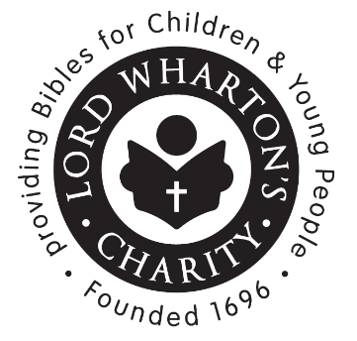
Providing Bibles for children
and young people
Please note: under the terms of the charity, this can only be in the
UK and for specific, individual, children
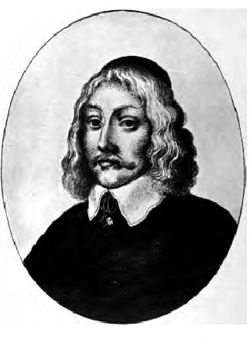

Philip, Lord Wharton
1613 - 1696
Philip, fourth Lord Wharton, came from a staunch Christian family. He was well-educated and well-travelled. During the Civil War he supported Parliament but opposed the execution of King Charles the first. He welcomed King Charles the Second at the Restoration and later became a Privy Councillor to King William the Third.

Six years before his death, Lord Wharton began distributing Bibles to children, and in his will he left 463 acres of land to fund the continuation of this work. The Trustees of Lord Wharton’s Charity continue to follow his wishes by distributing Bibles to children and young people so that they can be encouraged to use it for their own personal study.

http://www.lordwhartonbibles.org.uk
Lord Wharton’s Charity: founded 1696
Registered Charity Number 200298
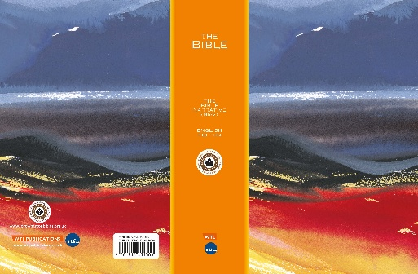
Lord Wharton’s Charity
Application Form – Applicant Details

Please complete this form in BLOCK CAPITALS

Name of Applicant

…………………………………………………….

Church / Organisation

…………………………………………………….

Position held

…………………………………………………….

Your Address (include postcode, UK only)

…………………………………………………….

…………………………………………………….

Phone Number

…………………………………………………….

E-mail Address

…………………………………………………….

I wish to apply for the Bibles shown opposite.
I will distribute them in accordance with the rules of the Lord Wharton’s Charity.

Applications can be emailed to the clerk
Signature (digital is acceptable)

………....................................

Date ......................................................

Date last application made (if applicable):

…………………………………………………….
If the Bibles need to be sent to an address other than the one above,
please write it clearly here:

…………………………………………………….

…………………………………………………….

…………………………………………………….
Lord Wharton’s Charity
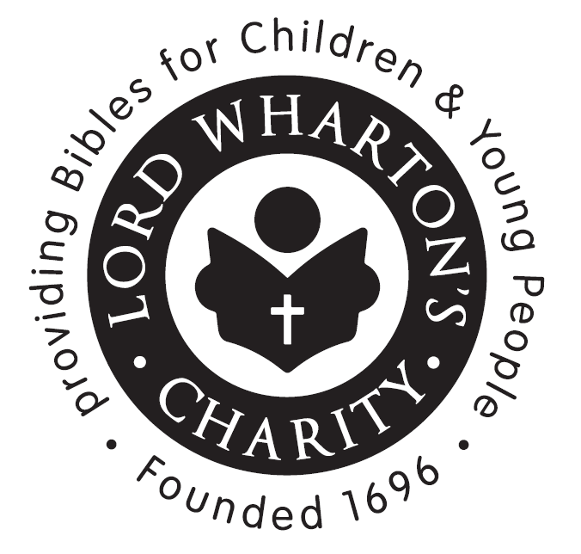
Application Form - Bible Request
Number of NIRV Bibles required
(see notes overleaf)

…………………………………………………….
We will not now supply other versions.

The Bibles are for distribution in:
(please name either the church
or the school and year group)
NB only in England, Wales & Scotland

…………………………………………………….

…………………………………………………….

Please confirm the Bibles will be
given to individual young people

Please X if a supporting letter is

attached or to be sent separately
If the church or school requires extra Bibles please X if you are willing to pay the difference in cost and an invoice will be sent

PLEASE RETURN THIS FORM
By email to - info@lordwhartonbibles.org.uk

The Clerk to the
Lord Wharton Charity Trustees
12 Copse Place
Steeton
KEIGHLEY
West Yorkshire
BD20 6FD

For further details or any questions contact:
Rev Peter Sheasby
07761 652008
info@lordwharton
peter.sheasby@methodist.org.uk
App 2026

